SECTION A (40 MARKS)
1. Give one health habit one should practice to avoid food contamination.
_____________________________________________________________________
2. Which body organ does Hepatistis affect?
_____________________________________________________________________
3. Give any one example of a fossil fuel.
_____________________________________________________________________
4. Besides being vertebrate, how else are birds similar to mammals?
_____________________________________________________________________
5. Why is it necessary to drain stagnant water around a home?
_____________________________________________________________________
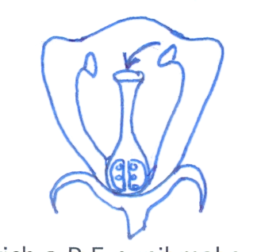
6. On the diagram below, label with letter x the part that produces pollen grains.

7. Apart from capital, give one other requirement for starting a livestock farm?
_____________________________________________________________________
8. Identify one accident that requires the use of splints in giving firstaid.
_____________________________________________________________________
9. Give one exotic breed of goat reared for milk production.
_____________________________________________________________________
10. Name the energy resource obtained from animal dung and urine.
_____________________________________________________________________
11. State one way of reducing echoes in a hall.
_____________________________________________________________________
12. Give one reason why we use toothpaste for brushing teeth.
_____________________________________________________________________

13. The diagram below shows a horse shoe magnet. Identify pole marked P.

_____________________________________________________________________
14. Give one disadvantage of free range system of poultry.
_____________________________________________________________________
15. Identify one condition in babies that causes drylips and a sunken soft spot on the head.
_____________________________________________________________________
16. Why are animals grouped under renewable resources?
_____________________________________________________________________
17. Which mineral salt is necessary for the formation of red blood cells in people?
_____________________________________________________________________
18. Apart from melting, state any one other physical change that takes place in the presence of
heat.
_____________________________________________________________________
19. Name the disease that affect both rabbits and poultry.
_____________________________________________________________________
20. Why does oil settle on top when mixed with water?
_____________________________________________________________________
21. Give one example of wading bird.
_____________________________________________________________________
22. In which method of making water clean do you first allow the impurities to settle at the
bottom of the container?
_____________________________________________________________________
23. State the piece of advice given to a person who suffers constipation.
_____________________________________________________________________
24. Why is maize grouped under monocotyledonous plants?
_____________________________________________________________________
25. How is the function of the pulmonary artery different from that of other arteries?
_____________________________________________________________________
_____________________________________________________________________
26. Which property of air enables you to drink soda using a straw?
_____________________________________________________________________
27. What name is given to disease caused due to lack of a certain food value in one’s diet?
_____________________________________________________________________
28. State one way in which married couples can avoid HIV/AIDS among themselves.
_____________________________________________________________________
29. In which way is the use of solar energy good to our environment?
_____________________________________________________________________
30. Which body system help to remove harmful waste products produced by the body cells?
_____________________________________________________________________
31. In which way can a donkey be used as an energy resource?
_____________________________________________________________________
32. What is a joint?
_____________________________________________________________________
_____________________________________________________________________
33. Mention one PIASCY message.
_____________________________________________________________________
34. Why is a pregnant woman said to be a vulnerable person?
_____________________________________________________________________
35. Which element of PHC promotes quick recovery?
_____________________________________________________________________
36. Describe one importance of a school health parade.
_____________________________________________________________________
37. Which component of soil is needed by plants to make food?
_____________________________________________________________________

38. State one similarity between a housefly and a fresh water snail.
_____________________________________________________________________
39. Which force enables us to walk?
_____________________________________________________________________
40. Give one secondary sex characteristic in boys.
_____________________________________________________________________
SECTION B (60 MARKS)
41. a) Which term refers to a sudden happening that results into injury or death?
_____________________________________________________________________
b) Give two examples of (a) above.
i) _________________________________ ii) _____________________________
c) State any one quality of a good firstaider.
_____________________________________________________________________
42. a) Name one exotic breed of cattle purposely reared for;
i) beef production ____________________________________________________
ii) milk production _____________________________________________________
b) State one way you can identify a beef breed from a dairy breed.
_____________________________________________________________________
c) Apart from beef and milk production, how else are cattle useful to people?
_____________________________________________________________________
43. a) What is seed dispesal?
____________________________________________________________________
_____________________________________________________________________
b) Name any two agents of seed dispersal.
i) _________________________________ ii) _____________________________
c) State one advantage of seed dispersal in the environment.
_____________________________________________________________________

44. The table below shows joint and their position in the human body. Study it and complete it
correctly.
Joint Position in the body
Pivot joint ________________________
______________________ shoulder
______________________ knee
Suture joint _______________________

45. a) Primary Five pupils were given two objects i.e an apple and a brick. Which method
would the pupils apply to find the volume of each.
- an apple __________________________________________________________
- a brick ___________________________________________________________
b) Name any equipment the pupils needed to have to find the volume of an apple.
_____________________________________________________________________
c) If the brick had a mass of 120gm and a density of 5gm/cc, what volume did they pupils
get?

_____________________________________________________________________
46. The diagram below shows the alimentary canal of man. Study it carefully and answer
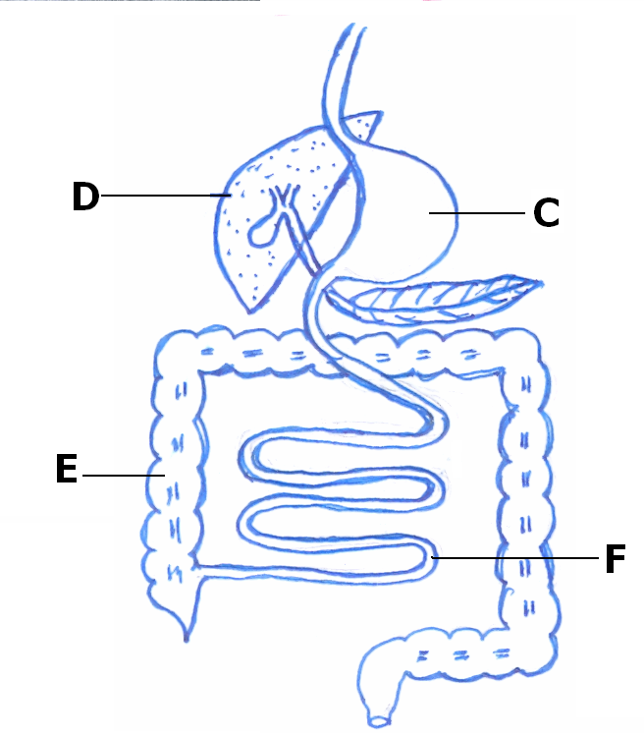
questions that follow.

B

a) Name the parts labelled D and F.
i) D _____________________________ ii) F ___________________________
b) Mention the digestive juice produced by B.
____________________________________________________________________
c) Why does digestion of food end in part F?
____________________________________________________________________

47. a) State any two differences between a housefly and a spider.
i) ________________________________________________________________
ii) ________________________________________________________________
b) Give one similarity between a housefly and a spider.
_____________________________________________________________________
c) Mention one disease spread by a housefly in people.
_____________________________________________________________________
48. a) Blood is a liquid tissue found in the body of most animals. Name any one component of
blood.
_____________________________________________________________________
- Give at least two functions of blood in the human body.
i) ________________________________________________________________
ii) ________________________________________________________________
c) In the space below, draw and name the shape of any blood cell.

49. a) Write STD in full.
_____________________________________________________________________
b) Give any one example of STDs caused by bacteria.
_____________________________________________________________________
c) Suggest any two dangers of premarital sex.
i) ________________________________________________________________
ii) ________________________________________________________________
50. a) State one danger of taking drugs without a medical workers instructional.
_____________________________________________________________________
b) Mention any two useful pieces of information written by a medical worker on a
prescription sheet given to a patient.
i) _________________________________ ii) _____________________________
c) Give any one reason why people take medical drugs.
_____________________________________________________________________
51. a) Give one way in which Primary Health Care(PHC) is a promoted in a family.
_____________________________________________________________________
b) State one way PHC is promoted by each of the following;
i) individuals ________________________________________________________
ii) community ________________________________________________________
c) Mention one role of a school health committee.
_____________________________________________________________________
52. a) What type of change takes place when a knife rust?
_____________________________________________________________________
b) Give two conditions necessary for rusting to take place in a knife.
i) _________________________________ ii) _____________________________
c) State any one effect of rusting on a knife.
_____________________________________________________________________
53. Match the source of energy to the type of electricity produced.
Source Type of electricity
flowing water solar electricity
hot springs thermal electricity
burning of coal hydro electricity
the sun for thermal electricity
i) flowing water __________________________________________________
ii) hot springs __________________________________________________
iii) burning of coal __________________________________________________
iv) the sun __________________________________________________

54. a) What is sound? ____________________________________________________
_____________________________________________________________________
b) John was hitting a drum 10m away from where Tom was sitting. How was Tom able to
hear the sound of the drum?
_____________________________________________________________________
c) How does a drum produce sound?
_____________________________________________________________________
d) Give any one natural source of sound.
_____________________________________________________________________
55. Name one example of a disease people are likely to get under the following condition.
i) poor disposal of faeces _______________________________________________
ii) poor feeding ______________________________________________________
- having unprotected sex ______________________________________________
- poor personal hygiene _______________________________________________
Good luck!

